

NAME: BISMA FATIMA
CLASS: CS A
ROLL NO: F24605036
COURSE: OBJECT ORIENTED PROGRAMMING
COURSE CODE: CS-123
LECTURER: MISS TAYYABA KALSOOM

Post LAB 04

TASK 07
1. public class SwapNumbers {
2. private int value;
3.
4. public SwapNumbers(int value) //parametric constructor
5. {
6. value = value;
7. }
8.
9. public int getValue() //returns the value
10. {
11. return value;
12. }
13.
14. public void setValue(int value) //method of class to set value
15. {
16. value = value;
17. }
18.
19. public static void swap(SwapNumbers n1, SwapNumbers n2)
20. {
21. int temp = n1.getValue();
22. n1.setValue(n2.getValue());
23. n2.setValue(temp);
24. }
25.
26. public static void main(String[] args) {
27. SwapNumbers num1 = new SwapNumbers(10);
28. SwapNumbers num2 = new SwapNumbers(20);
29.
30. System.out.println("Before swapping:");
31. System.out.println("num1 = " + num1.getValue());
32. System.out.println("num2 = " + num2.getValue());
33.
34. swap(num1, num2);
35.
36. System.out.println("After swapping:");
37. System.out.println("num1 = " + num1.getValue());
38. System.out.println("num2 = " + num2.getValue());
39. }
40. }

OUTPUT
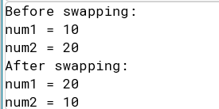
TASK 08
1. public class BankAccount {
2. private double balance;
3.
4. public BankAccount(double initialBalance) {
5. balance = initialBalance;
6. }
7.
8. public double getBalance() {
9. return balance;
10. }
11.
12. public void deposit(double amount) {
13. balance += amount;
14. }
15.
16. public void withdraw(double amount) {
17. if (balance >= amount) {
18. balance -= amount;
19. } else {
20. System.out.println("Insufficient funds");
21. }
22. }
23.
24. public static void main(String[] args) {
25. BankAccount account = new BankAccount(1000.0);
26.
27. System.out.println("Initial balance: " + account.getBalance());
28.
29. account.deposit(500.0);
30. System.out.println("Balance after deposit: " + account.getBalance());
31.
32. account.withdraw(200.0);
33. System.out.println("Balance after withdrawal: " + account.getBalance());
34. }
35. }

OUTPUT
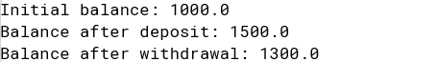
TASK 09
1. public class Rectangle1 {
2. private double length;
3. private double width;
4.
5. // Constructor
6. public Rectangle1(double length, double width) {
7. length = length;
8. width = width;
9. }
10.
11. // Method to calculate area
12. public void calArea() {
13. double area = length * width;
14. System.out.println("Area of the rectangle: " + area);
15. }
16.
17. // Method to calculate perimeter
18. public void calPerimeter() {
19. double perimeter = 2 * (length + width);
20. System.out.println("Perimeter of the rectangle: " + perimeter);
21. }
22.
23. public static void main(String[] args) {
24. // Create a Rectangle object
25. Rectangle1 rectangle = new Rectangle1(10.0, 5.0);
26.
27. // Calculate and display area and perimeter
28. rectangle.calArea();
29. rectangle.calPerimeter();
30. }
31. }

OUTPUT
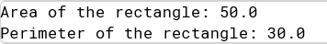
TASK 10
1. public class Employee1 {
2. private String name;
3. private double salary;
4. private int hoursOfWork;
5.
6. // Constructor
7. public Employee1(String name, double salary, int hoursOfWork) {
8. name = name;
9. salary = salary;
10. hoursOfWork = hoursOfWork;
11. }
12.
13. // Method to display employee information
14. public void showInfo() {
15. System.out.println("Name: " + name);
16. System.out.println("Salary: " + salary);
17. System.out.println("Hours of Work: " + hoursOfWork);
18. }
19.
20. // Method to increase salary by 20% if hours of work is greater than 8
21. public void addToSalary(double amount) {
22. if (hoursOfWork > 8) {
23. salary += (salary * 0.20);
24. System.out.println("Salary increased by 20% due to overtime work.");
25. } else {
26. System.out.println("No salary increase as hours of work is not more than 8.");
27. }
28. }
29.
30. // Method to deduct 5% from salary if hours of work is less than 5
31. public void deductFromSalary(double amount) {
32. if (hoursOfWork < 5) {
33. salary -= (salary * 0.05);
34. System.out.println("Salary deducted by 5% due to less working hours.");
35. } else {
36. System.out.println("No salary deduction as hours of work is not less than 5.");
37. }
38. }
39.
40. public static void main(String[] args) {
41. // Create an Employee object
42. Employee1 employee = new Employee1("John Doe", 5000.0, 9);
43.
44. // Display employee information
45. System.out.println("Initial Employee Information:");
46. employee.showInfo();
47.
48. // Increase salary
49. employee.addToSalary(0);
50.
51. // Display updated employee information
52. System.out.println("\nUpdated Employee Information after salary increase:");
53. employee.showInfo();
54.
55. // Create another Employee object
56. Employee1 employee2 = new Employee1("Jane Doe", 4000.0, 3);
57.
58. // Display employee information
59. System.out.println("\nInitial Employee Information:");
60. employee2.showInfo();
61.
62. // Deduct salary
63. employee2.deductFromSalary(0);
64.
65. // Display updated employee information
66. System.out.println("\nUpdated Employee Information after salary deduction:");
67. employee2.showInfo();
68. }
69. }
OUTPUT
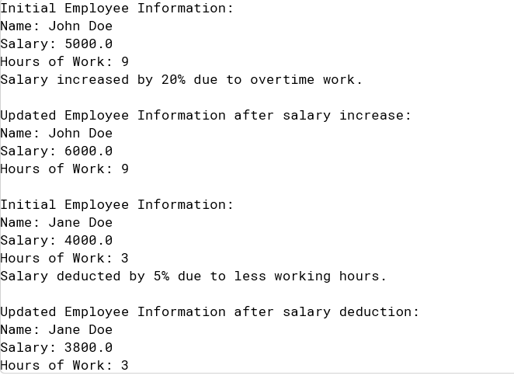
TASK 11
1. public class Account {
2. private String name;
3. private double balance;
4.
5. // Constructor
6. public Account(String name, double balance) {
7. this.name = name;
8. this.balance = balance;
9. }
10.
11. // Method to display account information
12. public void displayInfo() {
13. System.out.println("Account Holder's Name: " + name);
14. System.out.println("Current Balance: " + balance);
15. }
16.
17. // Method to deposit amount
18. public void deposit(double amount) {
19. balance += amount;
20. System.out.println("Deposit of " + amount + " made. Updated balance: " + balance);
21. }
22.
23. // Method to withdraw amount
24. public void withdraw(double amount) {
25. if (balance >= amount) {
26. balance -= amount;
27. System.out.println("Withdrawal of " + amount + " made. Remaining balance: " + balance);
28. } else {
29. System.out.println("Insufficient funds for withdrawal of " + amount + ".");
30. }
31. }
32.
33. public static void main(String[] args) {
34. // Create an Account object
35. Account account = new Account("John Doe", 1000.0);
36.
37. // Display initial account information
38. System.out.println("Initial Account Information:");
39. account.displayInfo();
40.
41. // Deposit amount
42. account.deposit(500.0);
43.
44. // Withdraw amount
45. account.withdraw(200.0);
46.
47. // Attempt to withdraw more than the balance
48. account.withdraw(1500.0);
49. }
50. }

OUTPUT
